

**Web Profiling and Scoping Tool**

**User Guide**

**Indiana University, Bloomington**

**Computer Science**

**Spring Semester, 2016**

**Team Members**

Abhijit Karanjkar

Ajinkya Dhamnaskar

Amruta Kamat

Gagandeep Singh

Pranav Pande

**Loading a chrome extension**

An extension can be loaded into google chrome by following the below steps. The extension can be accessed through a clickable icon right next to Chrome's Omnibox for easy access.

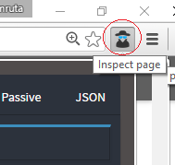

The very first thing we'll need to create is a manifest file named manifest.json. This manifest is nothing more than a metadata file in JSON format that contains properties like your extension's name, description, version number and so on.

{

"manifest_version": 2,

"name": "Getting started  
example",

"description": "This extension shows a Google  
Image search result for the current page",

"version": "1.0",

"browser_action": {

"default_icon": "icon.png",

"default_popup": "popup.html"

},

"permissions": [

"activeTab",

"https://ajax.googleapis.com/"

]

}

Few important elements of manifest.json:

* manifest_version: version of manifest file
* name: name of the extension
* default_icon: icon displayed next to the Omnibox, waiting for user interaction.
* default_popup: extension landing page
* page: background page
* permissions: specific permissions for extension
* content_security_policy: custom content security policies for extension

Loading the extension:

1. Goto chrome://extensions in your browser.

2. Check the Developer mode checkbox in the top right-hand corner.

3. Click Load unpacked extension… to pop up a file-selection dialog.

4. Navigate to the directory in which your extension files live, and select it.

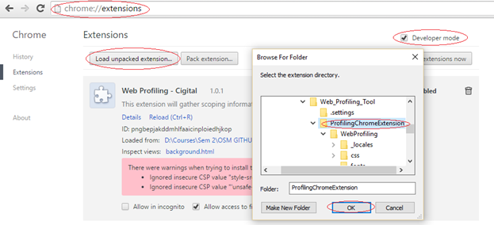

Alternatively, you can drag and drop the directory where your extension files live onto chrome://extensions in your browser to load it.

If the extension is valid, it'll be loaded up and active right away! If it's invalid, an error message will be displayed at the top of the page. Correct the error, and try again.

**Description of extension functionalities**

1. **Extension Home**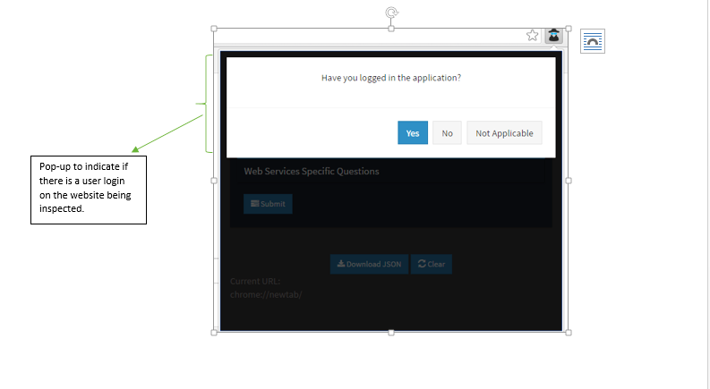

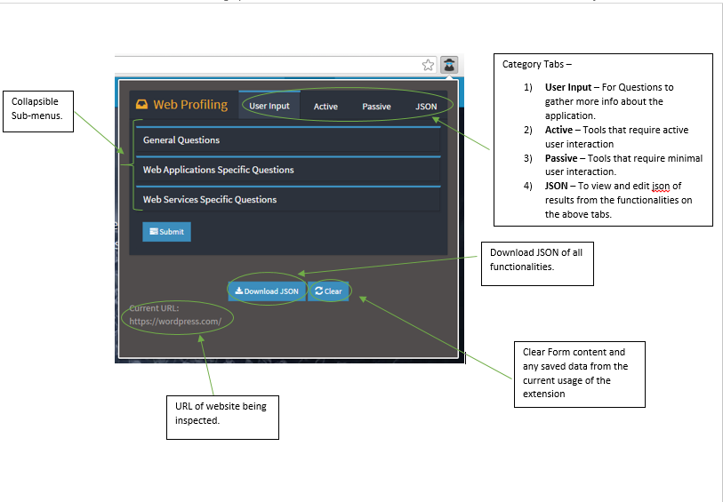

**2. 1) User Input tab -**

1. **General Questions -** These are general questions regarding the application to be filled by the user. The very first question is to enter the name of the application which is a mandatory question. The application name would be required to download the JSON file using Download JSON button.

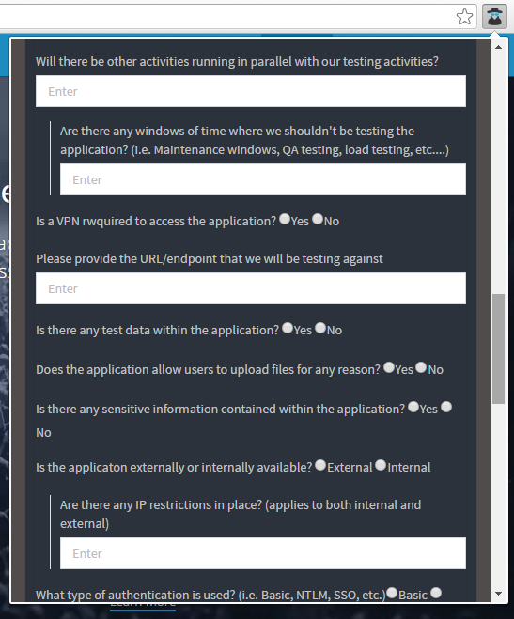

**b) Web Application Specific Questions -**

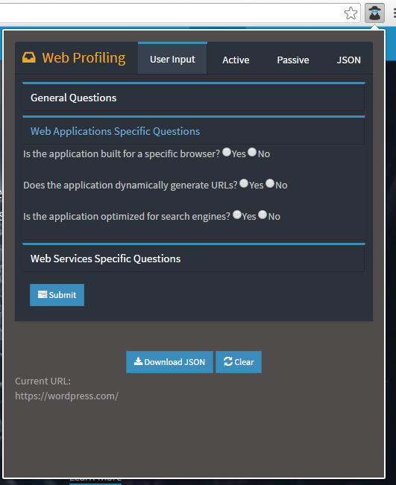

**c) Web Services Specific Questions -**

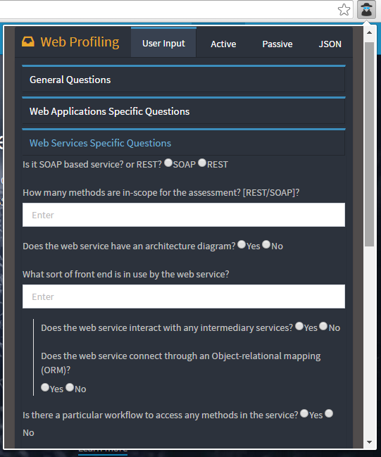

**2) Active tab**

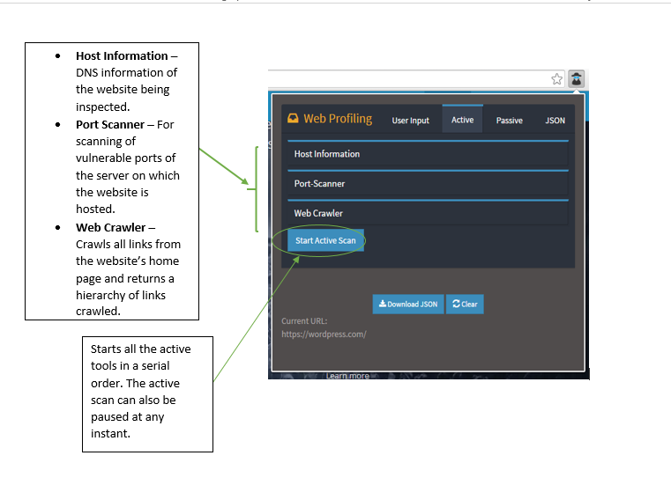

1. **Host Information**

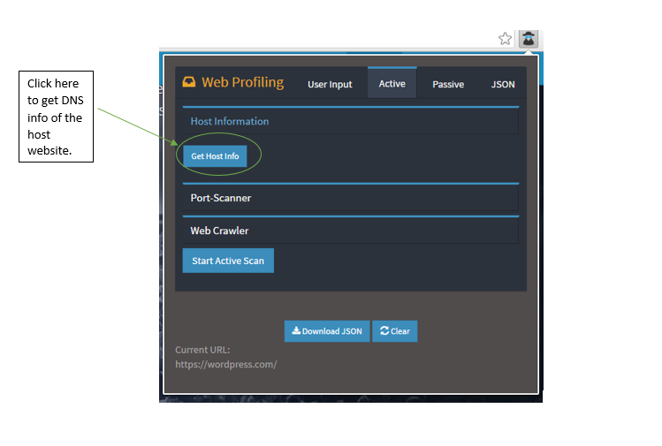

**b) Port Scanner**

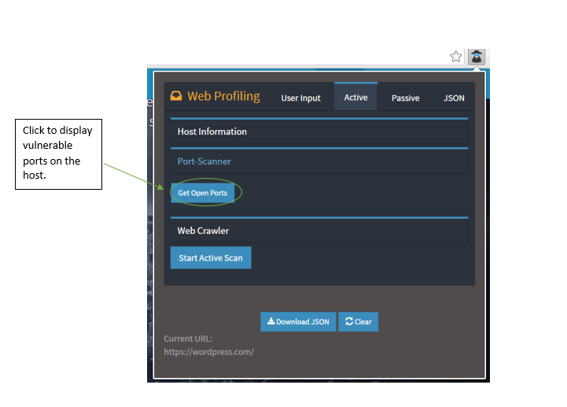

**c) Web Crawler**

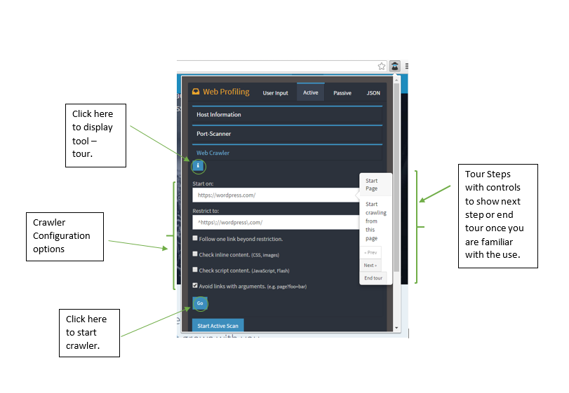

**3) Passive Tab**

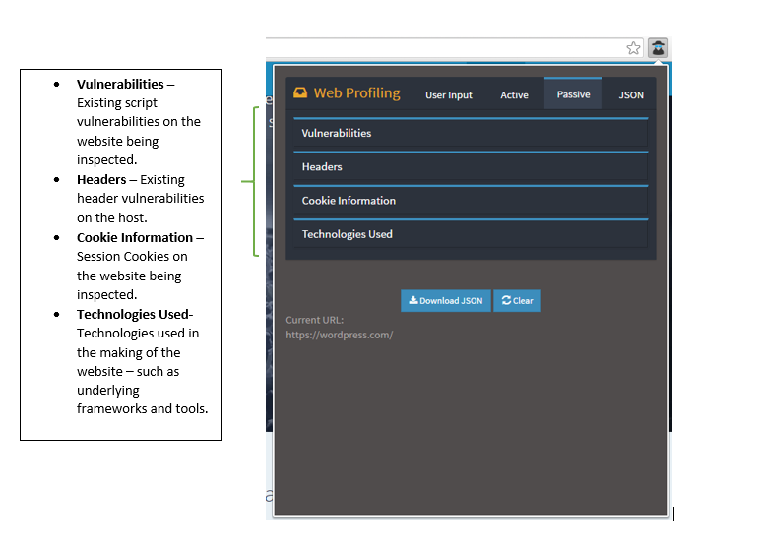

1. Vulnerabilities

1. Header Information -

HTTP headers are the request to a server for information and the resulting response. When you type an address into your browser it sends a request to the server hosting the domain and the server responds. Our tool provides information such as date of request, server details, cookies, content length and content type.

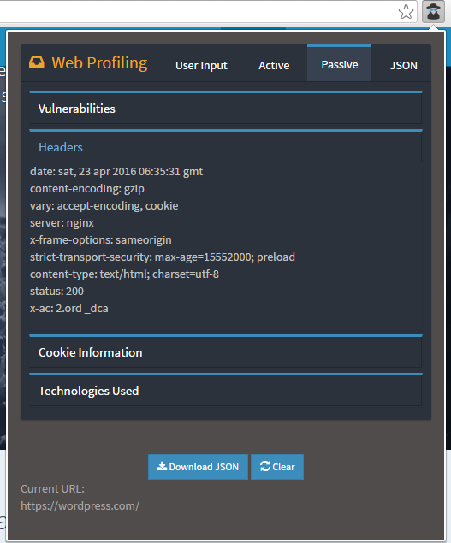

1. Cookie Information:

This feature saves cookies related to the current tab and you can view the stored data in Cookie Information section of Passive tab. The login information popup which appears on the launch of the tool has three buttons - Yes, No, Not Available. If use clicks No/Not Available then cookie info will be stored as data before login and and when user clicks Yes then cookie info will stored as data after login.

